

Project Title: AI-Powered Cephalometric Landmark Detection Using Deep Learning

Authors:
Name | Student ID
A M Musa Shakib Khan | 17121073

Submission Date: 25 June 2026
GitHub Repository: https://github.com/thegreatone9/CephalometryLandmarkDetection

Advanced Training on Semiconductor and ICT Technology
BRAC University
Table of Contents
1. Introduction 1
1.1 Brief Introduction 1
1.2 Problem Statement 1
1.3 Objectives 1
2. Dataset and Preparation 1
2.1 Dataset Description 1
2.2 Data Access 1
2.3 Preprocessing 2
3. Methodology 2
3.1 Course Techniques Used 2
3.2 Model Architecture 2
3.3 Training Strategy 2
4. Experiments and Results 3
4.1 MLflow Tracking 3
4.2 Evaluation Results 3
5. Prediction App and Docker 3
5.1 Prediction Pipeline 3
5.2 Prediction UI 4
5.3 Docker Serving 4
6. Repository and Reproducibility 4
6.1 Repository Structure 4
6.2 GitHub Rules 4
6.3 Reproducibility 5
7. Limitations and Future Work 5
7.1 Limitations 5
7.2 Future Improvements 5
8. Conclusion 5
Appendix 6
A. Final Submission Checklist 6
B. Final Notes 6

1. Introduction

1.1 Brief Introduction
This project belongs to the medical image analysis with deep learning domain. It implements an end-to-end AI system for cephalometric landmark detection — the automated identification of anatomical reference points on lateral skull X-rays (cephalograms).
In orthodontics, a cephalometric analysis is the standard diagnostic procedure for assessing jaw alignment. Clinicians manually mark anatomical points on an X-ray, draw lines between them, and measure angles to determine whether the upper jaw, lower jaw, and skull base are in normal proportion. This project automates the entire process using a deep learning model trained on expert-annotated data.
The final system accepts a lateral skull X-ray as input, detects 6 anatomical landmarks with sub-millimeter precision, computes three primary clinical angles (SNA, SNB, ANB), and displays a plain-English interpretation through an interactive Streamlit web interface served via Docker.

1.2 Problem Statement
Manual cephalometric landmark placement is time-consuming (5–10 minutes per X-ray), subject to inter-operator variability (~0.5mm between practitioners), and susceptible to fatigue-related errors in high-volume clinics.
- Input: A lateral skull X-ray image (cephalogram) in PNG, JPG, or BMP format.
- Output: 6 detected landmark positions overlaid on the X-ray, SNA/SNB/ANB angle measurements, clinical classification (Class I/II/III), per-landmark confidence scores, and plain-English interpretation.
- Users: Orthodontic researchers, dental students, and clinical teams seeking to automate or validate landmark placement.
- An automated system achieving near-expert accuracy reduces workload, improves consistency, and makes cephalometric screening more accessible.

1.3 Objectives
1. Train a deep learning model to detect 6 cephalometric landmarks with Mean Radial Error below 2mm.
2. Track all experiments with MLflow, logging hyperparameters, loss curves, evaluation metrics, and model artifacts.
3. Conduct multiple training runs with different configurations (encoder architecture, input resolution) to compare results.
4. Build a Streamlit prediction app for real-time landmark detection with angle measurements and clinical interpretation.
5. Containerize the prediction app using Docker for reproducible deployment.
6. Automate dataset download, setup, training, and deployment through a unified shell script (run.sh).

2. Dataset and Preparation

2.1 Dataset Description
The dataset used in this project:
Property | Value
Dataset name | Aariz — A Benchmark Dataset for Automatic Cephalometric Landmark Detection
Source | Figshare: doi:10.6084/m9.figshare.27986417.v1
Paper | Khalid et al., Scientific Data 12, 1336 (2025)
Total samples | 1,000 lateral cephalographic X-rays
Split | 700 training / 150 validation / 150 test
Annotation targets | 29 cephalometric landmarks (this project uses 6)
Annotators | Two independent groups: Junior and Senior Orthodontists
Input type | Grayscale images (PNG, JPG, BMP) from 7 X-ray machines
Target/output | (x, y) pixel coordinates per landmark, in JSON format
Additional metadata | Per-image pixel spacing (mm/pixel) for converting pixel errors to mm
URL | https://www.nature.com/articles/s41597-025-05542-3
Total samples: 1,000 lateral cephalographic X-rays. Split: 700 training / 150 validation / 150 test. Input type: Grayscale images (PNG, JPG, BMP) from 7 different X-ray machines. Annotations: 29 cephalometric landmarks in JSON format (this project uses 6). Annotators: Two independent groups (Junior and Senior Orthodontists).

The 6 landmarks used in this project:
Symbol | Landmark | Description
S | Sella | Center of the pituitary fossa
N | Nasion | Bridge of the nose — junction of frontal and nasal bones
A | A-point | Deepest concavity on the anterior upper jaw
B | B-point | Deepest concavity on the anterior lower jaw
Pog | Pogonion | Most anterior point of the chin
Me | Menton | Lowest point of the chin

2.2 Data Access
The dataset is sourced from Figshare and can be downloaded automatically using the included script src/data_download.py. The script downloads the ~2 GB archive, extracts it into data/, and validates the expected directory structure (train/, valid/, test/ with Cephalograms/ and Annotations/ subdirectories).

2.3 Preprocessing
Annotation parsing: JSON annotation files are parsed with symbol-based landmark lookup. Coordinates from Junior and Senior Orthodontist groups are averaged to produce more robust ground truth.
Image preprocessing: Images are resized to 512×512 pixels, converted to grayscale, and normalized to [0, 1].
Heatmap generation: The model is trained on Gaussian heatmaps — one 512×512 channel per landmark, with a 2D Gaussian peak centered at each landmark position (σ=5.0 pixels).
Data augmentation (training only): Albumentations keypoint-aware pipeline — random rotation (±15°), random brightness/contrast, and Gaussian noise. No augmentation during validation or test evaluation.

3. Methodology

3.1 Course Techniques Used
The following techniques from the course were applied in this project:

Technique | Where used
Transfer Learning | src/models/unet.py — ResNet34 pretrained on ImageNet with differential LRs
Data Preprocessing & Augmentation | src/data/dataset.py, src/data/preprocessing.py — Albumentations keypoint-aware pipeline
CNN Deep Learning (U-Net) | src/models/unet.py — U-Net with ResNet34 encoder, ~24M parameters
Model Training & Optimization | src/training/trainer.py — MSE loss, Adam optimizer, ReduceLROnPlateau scheduler
Hyperparameter Comparison | train.py — 3 runs comparing encoder (ResNet34 vs EfficientNet-b0) and resolution (512px vs 640px)
MLflow Experiment Tracking | src/training/mlflow_utils.py — hyperparameters, loss curves, metrics, model artifacts
Model Evaluation | src/evaluation.py — MRE in mm using per-image pixel spacing, SDR at 2/2.5/3/4mm
Dockerization | Dockerfile — CPU-only production container serving Streamlit app
API/UI Model Serving | app/streamlit_app.py — interactive web app with upload, inference, and interpretation
Reproducible Project Structure | run.sh — unified CLI for setup, training, Docker, MLflow

3.2 Model Architecture
Architecture: U-Net with ResNet34 encoder pretrained on ImageNet, from segmentation-models-pytorch. Input: [1×512×512] grayscale. Output: [6×512×512] Gaussian heatmaps (one per landmark). Post-processing: Argmax peak detection → weighted centroid refinement for sub-pixel accuracy → confidence scoring.
Model pipeline:

Input: [1 × 512 × 512] (single-channel grayscale X-ray)
↓
ResNet34 Encoder (pretrained, ~21M params)
| 5 stages of downsampling, skip connections preserved
↓
U-Net Decoder (~3M params)
| 5 upsampling blocks, restores 512×512 resolution
↓
Output: [6 × 512 × 512] (one Gaussian heatmap per landmark)
↓
Weighted Centroid Refinement
| Argmax peak → intensity-weighted center of mass
↓
6 × (x, y) coordinates + confidence scores (0–100%)

Key hyperparameters:
Parameter | Value
Loss function | MSE on heatmaps
Optimizer | Adam with differential LR (encoder: 1e-4, decoder: 1e-3)
LR scheduler | ReduceLROnPlateau (patience=5, factor=0.5)
Heatmap sigma | σ = 5.0 pixels
Input resolution | 512 × 512 pixels
Total parameters | ~24M
Pretrained weights | ImageNet

3.3 Training Strategy
Training was conducted on an Apple M4 GPU (MPS backend) with batch size 4 for 50 epochs. The model is evaluated on the validation set after every epoch. The checkpoint with the lowest validation loss is saved to a run-specific directory (e.g. checkpoints/resnet34-ep50-bs4-img512/best_model.pth).
Three training runs were conducted: (1) ResNet34 @ 512px, (2) ResNet34 @ 640px, and (3) EfficientNet-b0 @ 512px. The hardware auto-detects MPS, CUDA, or CPU.
Best model selection: The best-validation-loss checkpoint is always used for final test evaluation — not the final epoch's weights. This protects against late-training overfitting.

4. Experiments and Results

4.1 MLflow Tracking
All training runs are logged to a local MLflow SQLite database (mlflow.db).
Parameters logged: encoder_name, epochs, batch_size, image_size, sigma, encoder_lr, decoder_lr.
- Metrics logged: train_loss and val_loss per epoch; mre_overall_mm; per-landmark MRE; SDR at 2.0/2.5/3.0/4.0mm.
- Artifacts saved: Best model checkpoint (best_model.pth) per run.
- Runs completed:
Run Name | Encoder | Resolution | Status
resnet34-ep50-bs4-img512 | ResNet34 | 512px | FINISHED
resnet34-ep50-bs4-img640 | ResNet34 | 640px | FINISHED
efficientnet-b0-ep50-bs4-img512 | EfficientNet-b0 | 512px | FINISHED
- Best run: resnet34-ep50-bs4-img512 — lowest MRE (0.78mm), highest SDR@2mm (94.9%), most stable training.
- The MLflow UI can be launched with ./run.sh mlflow start (http://localhost:5000).
MLflow experiment comparison (3 runs):
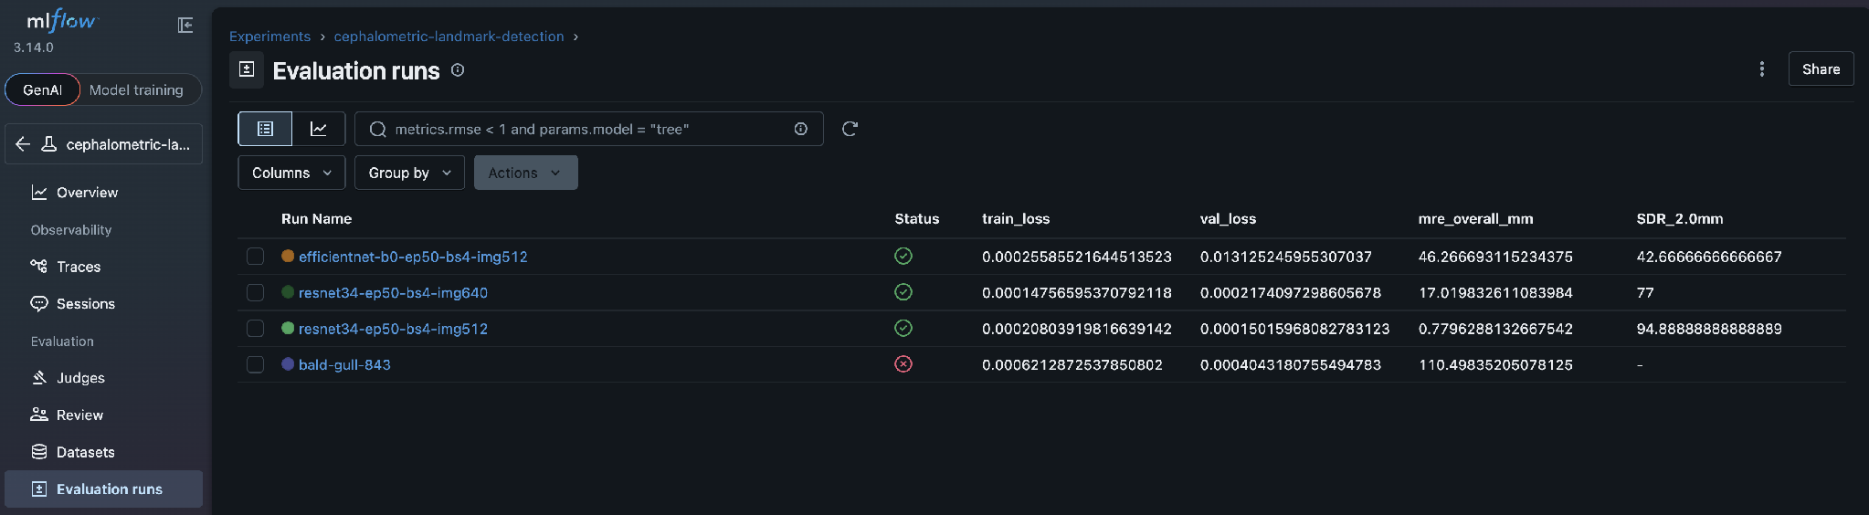

4.2 Evaluation Results
Three-run comparison (all 50 epochs on Apple M4 GPU):
Metric | Run 1: ResNet34 @ 512px | Run 2: ResNet34 @ 640px | Run 3: EfficientNet-b0 @ 512px
Overall MRE | 0.78 mm ✅ | 17.02 mm | 46.27 mm
SDR @ 2.0mm | 94.9% | 77.0% | 42.7%
SDR @ 2.5mm | 97.4% | 80.0% | 45.7%
SDR @ 3.0mm | 98.8% | 81.8% | 47.0%
SDR @ 4.0mm | 99.7% | 82.8% | 48.1%
Best val loss | 0.000390 (epoch 4) | 0.000074 (epoch 49) | 0.000272 (epoch 29)
Training stability | Stable | Stable | Highly oscillating

Per-landmark accuracy (production model — Run 1):
Landmark | MRE (mm)
Menton (Me) | 0.51
Pogonion (Pog) | 0.61
Sella (S) | 0.73
B-point (B) | 0.92
Nasion (N) | 0.94
A-point (A) | 0.98

Run 1 (ResNet34 @ 512px) places 94.9% of landmarks within the 2mm clinical threshold, surpassing literature SOTA for single-stage models (~80-90%) and approaching human inter-observer accuracy (0.49mm). Run 2 (640px) failed on Sella due to proportionally narrower Gaussian target. Run 3 (EfficientNet-b0) showed unstable training with 4 of 6 landmarks failing.
Per-landmark accuracy (production model — Run 1):
Training loss curves (best run — ResNet34 @ 512px):
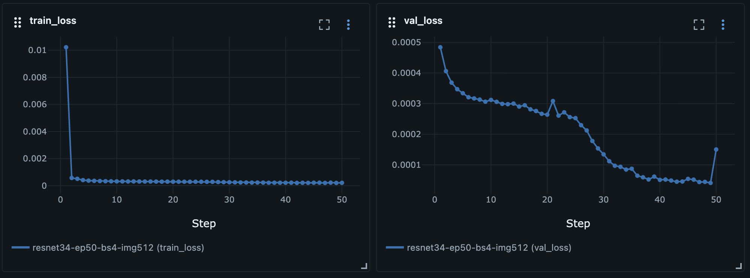

5. Prediction App and Docker

5.1 Prediction Pipeline
The inference pipeline works as follows:
1. Upload: User uploads a lateral skull X-ray or loads a sample image via the Streamlit UI.
2. Preprocessing: Image resized to 512×512, converted to grayscale, normalized to [0,1], formatted as tensor [1, 1, 512, 512].
3. Inference: Tensor passed through the U-Net → 6 heatmaps [1, 6, 512, 512].
4. Coordinate extraction: Argmax finds peak pixel per channel; weighted centroid refinement computes intensity-weighted center of mass in a 21×21 patch for sub-pixel accuracy; confidence = normalized peak value.
5. Coordinate rescaling: 512×512 coordinates scaled back to original image dimensions.
6. Angle computation: SNA, SNB, and ANB computed from S, N, A, B coordinates using atan2-based vector angle computation.
7. Output: Annotated X-ray, angle measurements, clinical interpretation, and confidence bars displayed in the UI.

5.2 Prediction UI
The app is built with Streamlit (app/streamlit_app.py). The sidebar provides a checkpoint selector dropdown (newest model pre-selected). The main area shows image upload, two-column layout (annotated X-ray + angle metrics), full-width clinical interpretation in plain English, and per-landmark confidence bars with low-confidence warnings. Prediction app — upload interface and landmark detection output:
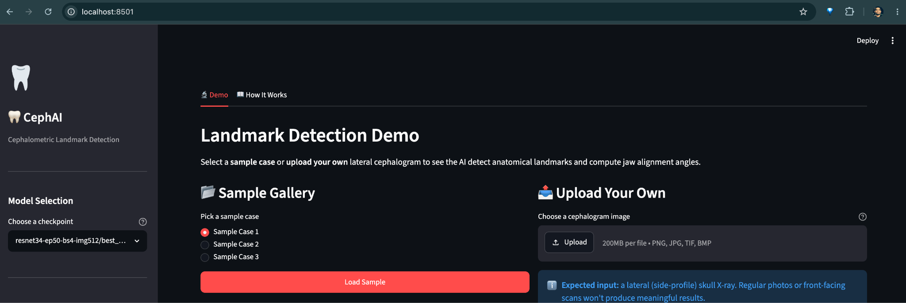

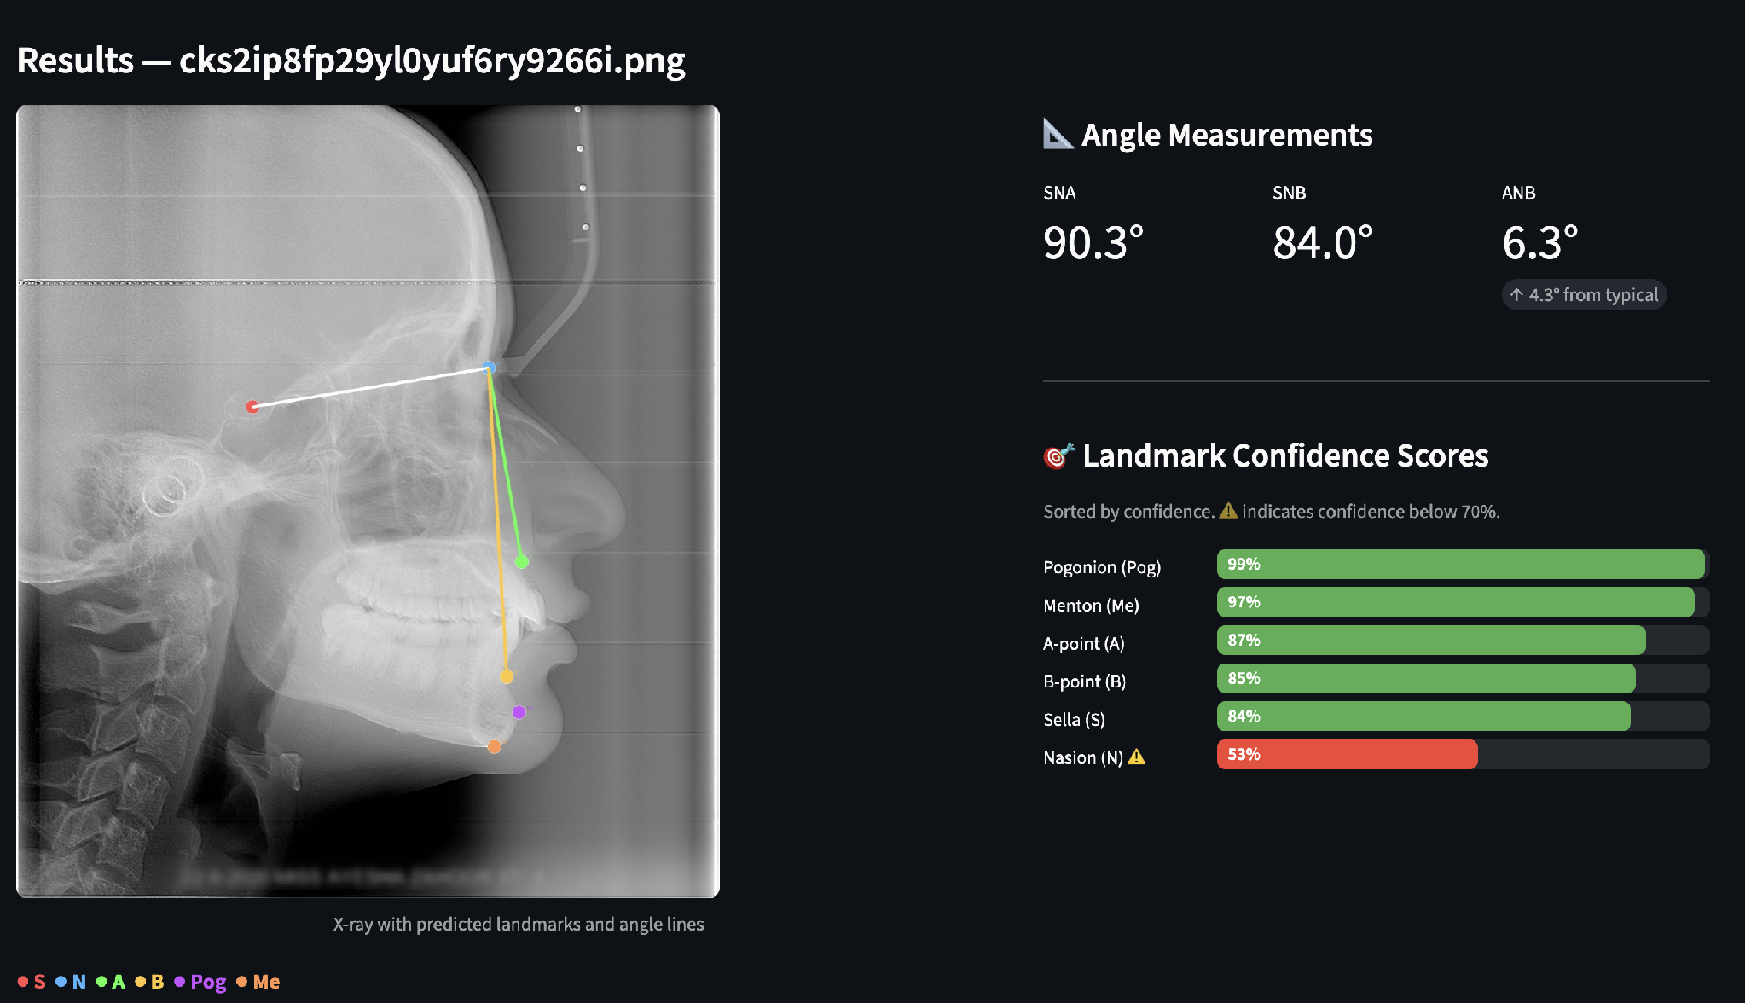
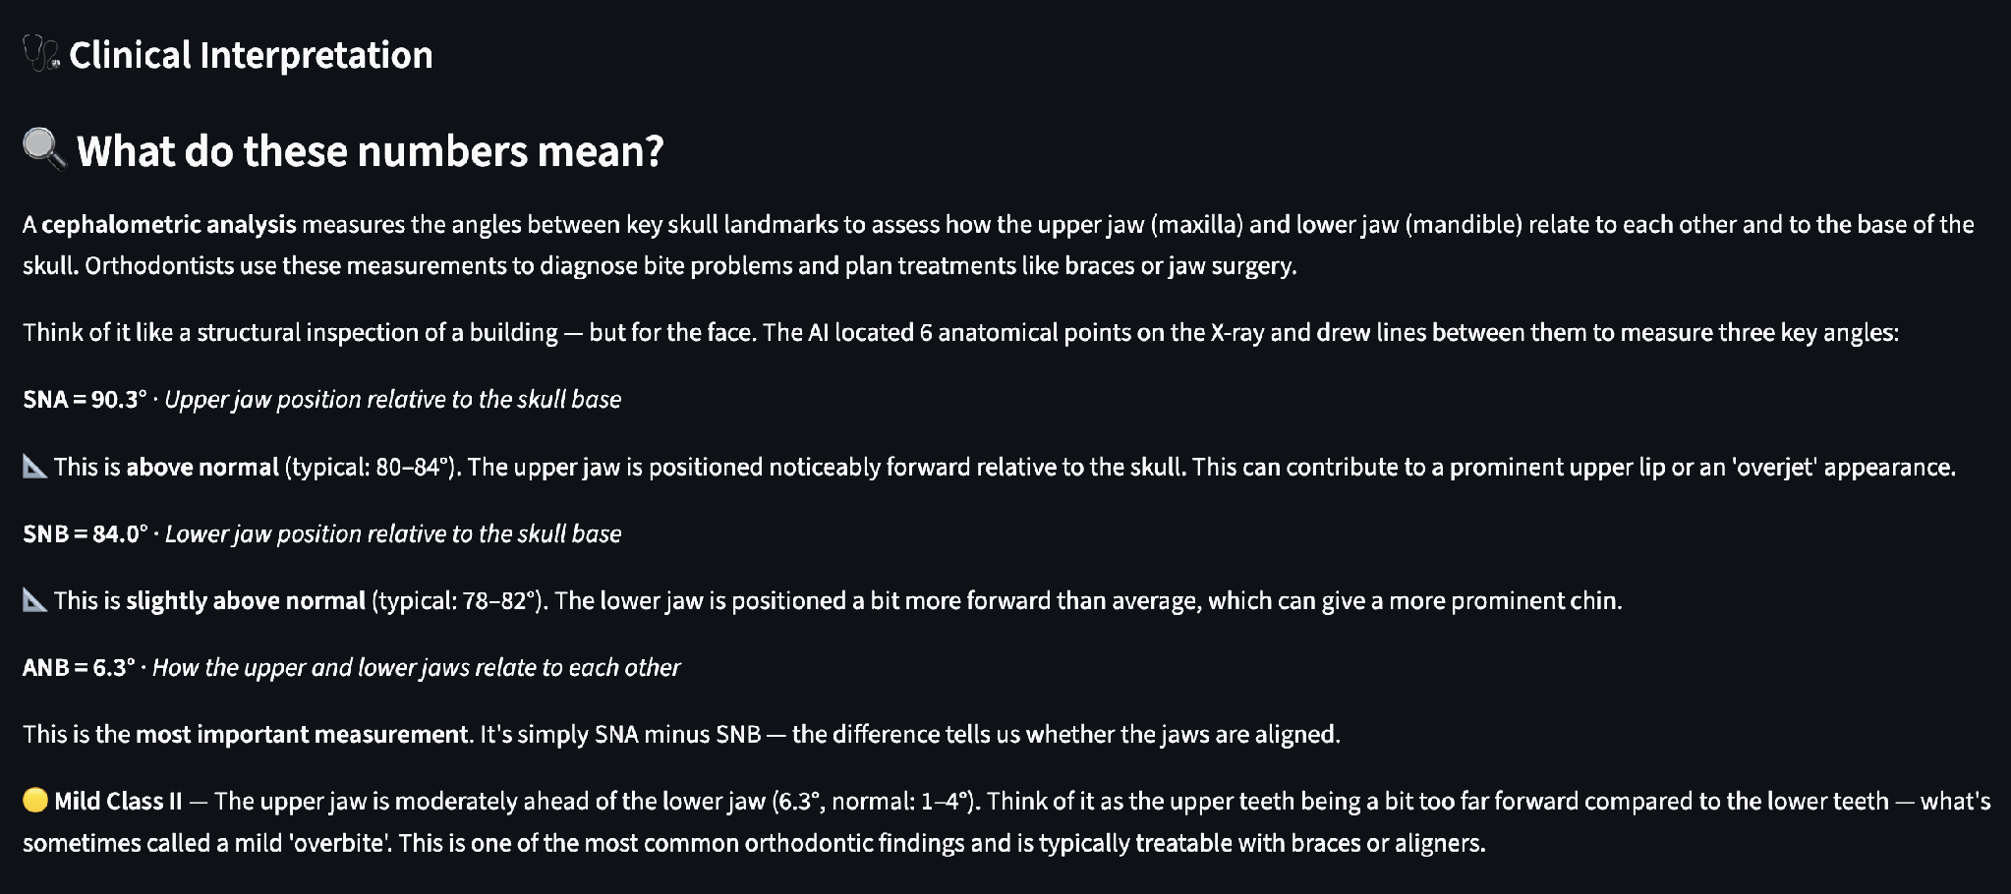

5.3 Docker Serving
The Dockerfile uses Python 3.12 slim with CPU-only PyTorch (requirements-docker.txt), bundling the trained checkpoint and sample images. Image size is approximately 2 GB, exposing Streamlit on port 8501. The repository README contains full build and run instructions.
To build and run:
docker build -t cephalometric-demo:0.1 .
docker run -d --name cephalometric-demo -p 8501:8501 cephalometric-demo:0.1
The app is then accessible at http://localhost:8501.
Docker-served prediction app:
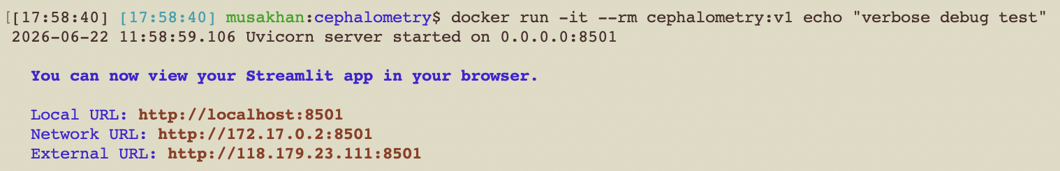

6. Repository and Reproducibility

6.1 Repository Structure
Repository structure:
CephalometryLandmarkDetection/
├── README.md # Full project documentation
├── final_report.md # This report
├── requirements.txt # Full dependencies (GPU-enabled)
├── requirements-docker.txt # CPU-only dependencies for Docker
├── .gitignore
├── Dockerfile
├── run.sh # Unified CLI
├── train.py # Training entry point
├── src/
│ ├── data_download.py # Automatic dataset downloader
│ ├── data/dataset.py # PyTorch Dataset class
│ ├── data/preprocessing.py # Augmentation pipelines
│ ├── models/unet.py # U-Net factory
│ ├── training/trainer.py # Training loop
│ ├── training/mlflow_utils.py # MLflow helpers
│ ├── inference/predict.py # Heatmap → coordinates
│ ├── inference/angles.py # Angle computation
│ ├── viz/overlay.py # Visualization
│ └── evaluation.py # MRE/SDR evaluation
├── app/streamlit_app.py # Prediction UI
├── screenshots/ # MLflow, Docker, demo screenshots
├── sample_images/ # Demo X-rays bundled in Docker
├── checkpoints/ # Trained model weights
└── data/ # Dataset (populated by data_download.py)

6.2 GitHub Rules
The .gitignore excludes: data/ (raw dataset), checkpoints/ (trained weights), mlruns/ and mlflow.db (MLflow tracking data), .venv/ (virtual environment), __pycache__/ (Python cache). Raw datasets, private credentials, and large artifacts are never committed.

6.3 Reproducibility
From a fresh clone:
(1) ./run.sh setup — creates virtual environment and installs dependencies.
(2) python src/data_download.py — downloads dataset from Figshare into data/.
(3) ./run.sh train --epochs 50 --batch-size 4 — trains the model with MLflow tracking.
(4) ./run.sh mlflow start — opens MLflow UI at http://localhost:5000.
(5) ./run.sh local start — starts Streamlit app at http://localhost:8501.
(6) ./run.sh docker build && ./run.sh docker start — builds and runs Docker container.

7. Limitations and Future Work

7.1 Limitations
1. Only 6 of 29 available landmarks are detected — insufficient for complete Steiner/Ricketts analysis.
2. Single-stage architecture — multi-stage refinement networks typically achieve higher precision.
3. Sella detection is sensitive to resolution changes without proportional sigma scaling.
4. EfficientNet-b0 showed unstable training with U-Net decoding and ResNet34 learning rates.
5. No soft-tissue landmarks used (available in dataset but not implemented).
6. Evaluated on a single dataset only — cross-dataset generalization untested.
7. CVM stage labels in the dataset are unused.

7.2 Future Improvements
1. Expand to all 29 landmarks for complete clinical cephalometric analysis.
2. Scale heatmap sigma with input resolution to prevent landmark detection failures.
3. Add a patch-level refinement network as a second stage for harder landmarks.
4. Tune EfficientNet with architecture-specific learning rates and skip connection adapters.
5. Include soft-tissue landmarks and CVM stage classification as multi-task outputs.
6. Cross-dataset evaluation against ISBI 2015 for generalization testing.
7. Ensemble prediction across multiple trained models for more robust outputs.

8. Conclusion
This project built a complete, reproducible deep learning system for automated cephalometric landmark detection. The production model (U-Net + ResNet34 @ 512px) achieves an overall Mean Radial Error of 0.78mm and places 94.9% of landmarks within the 2mm clinical acceptability threshold — surpassing literature SOTA for single-stage models and approaching human inter-observer accuracy.
Three training experiments tracked with MLflow demonstrated that ResNet34 outperforms EfficientNet-b0 for U-Net-based heatmap regression, and that input resolution must be carefully matched to the heatmap sigma to avoid failures on anatomically ambiguous landmarks.
The Streamlit prediction app, served via Docker, allows any user to upload a cephalogram and receive landmark overlays, angle measurements, clinical classification, and plain-English interpretation — requiring no orthodontic expertise to understand.

The project demonstrates transfer learning, heatmap regression, keypoint-aware augmentation, MLflow experiment tracking, Docker containerization, and interactive web-based model serving — techniques covered in the SICIP certification program.

Appendix

A. Final Submission Checklist
- Selected one approved project domain: Medical image analysis with deep learning.
- Public GitHub repository: github.com/thegreatone9/CephalometryLandmarkDetection
- Dataset is sourced externally and auto-downloaded via src/data_download.py.
- Data downloads into data/ automatically.
- Training uses MLflow (src/training/mlflow_utils.py).
- Three MLflow runs are logged (minimum two required).
- Report includes MLflow screenshot (screenshots/mlflow_runs.png).
- Prediction app supports image upload via Streamlit.
- Prediction app is served using Docker.
- Report includes Docker screenshot (screenshots/docker_app_running.png).
- Course techniques are clearly documented (Section 3.1).

